Staffing Management Plan

*Villamin Wood and Iron Works System*

Villamin Wood and Iron Works

G367+F29, MRT Ave

Taguig, 1632

May 2023

### **Introduction**

Having a strong project team that will manage and help structure the project is what human resource management strategies are. It is one of the most crucial parts to the success of the project, as it is help assist in establishing the appropriate and qualified people that will work on the project. This strategy includes the roles and responsibilities, communication protocols, and performance management issues.

With the use of this plan, the team can successfully manage the project as it will make sure that all team members are working effectively and understands their role and responsibilities, that communications are open, that their performance while working is monitored as their contribution to the success of the project.

### **Roles and Responsibilities**

For the project to be completed successfully, a strong human resources management strategy is essential of any project. It describes the duties and responsibilities of each member of the project team, stakeholders, making sure that everyone is aware of their contributions and how they fit into the overall picture.

The strategy also specifies the degree of authority and decision-making held by each team member, making sure that resources are distributed and used efficiently. By distinctly defining the strategy will ensure that the appropriate individuals are in the right positions based on their competencies and skill requirements to the appropriate roles to ensure project success.

This plan acts as the success of the project roadmap for the project team to execute and deliver.

|  |  |  |  |
| --- | --- | --- | --- |
| Roles | Authority | Responsibility | Competency |
| Project Sponsor | Approves the needed deliverables and budget of the project.  Provides feedback and comments on what can be improved.  Able to allot project resources and consent to project scope changes,  schedule and budgeting plan with significant effects. | Ensures that the project delivers the anticipated benefits and value and is in line with the organization's strategic goals and objectives.  Provide guidance to the project and project manager.  Communicate with the stakeholder and project manager for the progress of the project and team. | Communicating effectively with the team.  Strong leadership and strategic thinking skills.  Understands the team’s goal for the project.  Ability to support the project. |
| Product Owner | Make choices about the growth and direction of a product. They have the power to establish requirements, set priorities for the product backlog, and make critical decisions on the features, functionalities, and release timelines. | Responsible of representing the interests of the stakeholders, working with the development team, and making sure the product satisfies consumer needs and accomplishes business objectives. Throughout the course of the product's lifecycle, they are responsible for maximizing its value and making strategic decisions. | Stakeholder Management, Leadership and Collaboration Skills, Communication Skills, and Continuous Learning and Adaptability. |
| Project Manager | Authority to make decisions regarding the project.  Approve changes to project scope, schedule, and budget that has low change effect. | Control and help execute a solution to a problem in the project and monitors the work of the team members. | Strong leadership, communication skills, and project management skills. Knowledge of the company for precise information. |
| Developer | Designing, creating, and implementing software solutions in accordance with project needs and technical specifications are the domain of a developer. To guarantee the successful delivery of the software product, they have the authority to develop and edit code, create, and maintain software components, and work with team members. | Responsible to convert conceptual designs and specifications into useful software programs. They must write clear, effective, and well-documented code, perform unit tests to ensure functionality, and debug and fix software bugs. Work closely with product owner and project manager. | Programming Languages, Problem-Solving Skills, Technical Knowledge, Coding and Debugging, Collaboration and Teamwork, Time Management, and Continuous Learning. |
| Quality Assurance  (Internal User) | Ensures that products and deliverables fulfill its quality standards. Develop and implement quality processes, conduct testing, and checks the quality of the system and deliverables. | Ensures that the entire project deliverables and product are consistently meeting its quality standards. Ensure that the overall quality of the product and deliverables are met by establishing quality criteria, development processes, and implements corrective actions. | Technical Skills, Communication skills, Problem-solving skills, Collaboration, and Time Management. |
| Product/System Tester  (Internal Users) | Evaluate and validates the performance and functioning of a system or software program. Authority to find and report errors or problems, work with stakeholders and developers to fix them, and make improved suggestions. | Ensure that the system operates as intended and meets the quality standard set for it. Responsible for designing and executing test cases, identifying, and reporting defects, and verifying that the system meets the specified requirements. | Technical Skills, Communication Skills, Time Management, Analytic and Problem-Solving Abilities. |
| Customers  (External Users) | Test the project’s system. | Provides feedback on the project’s system.  Communicates with the team to help improve the system. | Communication skills.  Knowledge in using an online system. |
| Client  (External User) | Company Owner that introduced the project and will test the system. | Provides feedback on the deliverables and system. Communicates with the project sponsor, project stakeholder, and project manager for updates and progress. | Strong leadership, communication skills, and negotiation skills. |

Table 1: Roles and Responsibilities

### **Project Organizational Charts**

Project organizational chart is a visual representation of the relationship between the team and the key stakeholders. At the top of the chart comes the project sponsor, followed by the project stakeholder as they are responsible for communicating between the project sponsor and the rest of the team, and then followed by the project manager which is responsible for managing the project team, send approval requests for the deliverables, and schedules. The project team members are responsible for completing the deliverables and make sure that there’s progress on the tasks at hand.

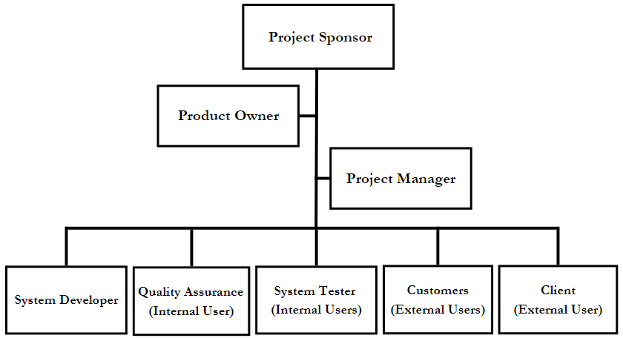

Figure 1: Project Organizational Chart

**Staffing Management**

Staffing Management is a crucial part of ensuring the success of the project. It shows the plans and process of the project, managing the acquired information, and it also shows the responsibilities and tasks of the human resources.

* Acquisition must be completed as soon as possible to obtain the skills and knowledge required for the project. This will involve using new employees, outside contractors, and even internal staff as needed to complete the project.
* Prior to anything else, training will be used to reduce errors in the project working environment and to further hone skills for better application in the creation and execution of deliverables appropriately.
* Regular performance evaluations will be done to evaluate the performance of team members and pinpoint potential improvement areas. These evaluations also comment on the team members' performance in achieving the project's goals objectives and expectations.
* A recognition and incentive program will be put in place to reward and encourage exceptional performance. This could apply to rewards, promotions, and other advantages.

Regular reviews and updates to the Staffing Management Plan will be made as necessary to Ensure that it continues to be in line with the project's requirements and objectives. It is crucial that the project manager perform a thorough analysis of the project's particular requirements and laws to ascertain whether any extra items need to be added to the management of staffing.

|  |  |  |  |  |  |
| --- | --- | --- | --- | --- | --- |
| Role | Project Responsibility | Skills Required | Number of Staff | Performance Review | Recognition and Rewards |
| Project Sponsor | Approves the needed deliverables and budget of the project. | Strong leadership and strategic thinking skills. | 1 | Quarterly or as needed | Promotion or Bonus |
| Product Owner | Responsible for maximizing its value and making strategic decisions. | Stakeholder Management, Leadership and Collaboration Skills, Communication Skills, and Continuous Learning and Adaptability. | 1 | Monthly or as needed | Promotion or Bonus |
| Project Manager | Control and help execute a solution to a problem in the project and monitors the work of the team members. | Strong leadership, and communication skills. | 1 | Weekly or as needed | Salary Increase |
| Developer | Responsible to convert conceptual designs and specifications into useful software programs. Work closely with product owner and project manager | Programming Languages, Problem-Solving Skills, Technical Knowledge, Coding and Debugging, Collaboration and Teamwork, Time Management, and Continuous Learning. | 2 | Weekly or as needed | Salary Increase |
| Quality Assurance | Ensures that the entire project deliverables and product are consistently meeting its quality standards. | Technical Skills, Communication skills, Problem-solving skills, Collaboration, and Time Management. | 1 | Weekly or as needed | Salary Increase |
| System Tester | Ensure that the system operates as intended and meets the quality standard set for it. Responsible for program. | Technical Skills, Communication Skills, Time Management, Analytic and Problem-Solving Abilities. | 1 | Weekly or as needed | Salary Increase |

Table 2: Staffing Management